What Are the Rules On the Treatment Of Estimated Financial Assistance (EFA)?
This guidance is not award-year-specific and applies across award years.
This AskRegs Knowledgebase Q&A was updated on January 25, 2022 to add #11 through #13 below. This is not a change in guidance, however.
Please see the definition of estimated financial assistance in 34 CFR 685.102(b), specifically, clause (1)(iii), which states: "Estimated financial assistance: (1) The estimated amount of assistance for a period of enrollment that a student (or a parent on behalf of a student) will receive from Federal, State, institutional, or other sources, such as scholarships, grants, net earnings from need-based employment, or loans, including but not limited to- ... (iii) Any educational benefits paid because of enrollment in a postsecondary education institution, or to cover postsecondary education expenses;..." The assumption for this part of the definition is that the student would not be receiving the assistance if he or she was not enrolled at a postsecondary institution. [685.102(b)] See also 673.5(c) Estimated financial assistance.
It is usually fairly clear that scholarships and prizes are awarded contingent on enrollment, but let's look at an example. A woman wins a beauty pageant that is limited to students at a certain school; the prize is a $500 scholarship. Did the student win the award because she was enrolled? Yes, she did. She had to be enrolled in order to enter the contest. The scholarship is financial aid, even though it was won based on a pageant. As such, that prize would be considered EFA when packaging the student.
Institutions are afforded a great deal of flexibility when awarding non-Title IV funds, and regardless of what an educational benefit is called and who awards it, institutions should be careful that such awards do not to circumvent the Title IV overaward provisions and the spirit of the law. Having said that, the determination of whether or not a scholarship, gift, prize, etc. is based on postsecondary enrollment remains an institutional decision. Terms for which there are no federal definitions often lack standard usage.
To determine how a given award must be treated, the financial aid administrator must look beyond the name the award carries, to the characteristics of the award. How such awards and benefits are treated when calculating need and packaging or awarding Title IV funds comes down to the definitions of such terms as wages, income, employment, and compensation and the institution's own determination as to which definition applies to each type of award/benefit in question.
The following rules and observations should help the financial aid administrator analyze the award and determine its proper treatment.
GENERAL RULES: Essentially, to determine proper treatment, the financial aid administrator needs to decide whether an award or benefit is income to be used in calculating the expected family contribution (EFC) or if it is financial aid [i.e., EFA] to be used in meeting the student's need. If the benefit is employment, this determination further involves characterizing the employment as either need-based or non-need-based.
1) An award or a benefit used as EFA for the purpose of packaging Title IV funds may not be included in the calculation of the EFC.
2) Whether the award or benefit is taxed or untaxed does not affect whether it is used as EFA in the package.
3) If an award or a benefit or a portion of an award/benefit is considered employment according to federal or state guidelines, the school must treat it as employment.
4) Before the school can account for employment in the student's aid package, it must determine whether the employment is need-based or non-need based.
5) The Federal Methodology (used to establish need for Title IV programs) does not have to be used to determine a student's need for employment; if any system of need determination is used, the employment is considered to be need-based (even if a student doesn't demonstrate need).
6) Need-based employment is always treated as EFA when packaged with other Title IV aid.
7) Non-need-based employment is never treated as EFA; rather, it is treated as income in the calculation of the EFC.
8) Other than non-need-based employment, an award or benefit that is contingent upon the student's enrollment is generally treated as EFA, since it is probably going towards educational expenses.
9) If it covers an educational expense that can be included in the student's cost of attendance (COA), any funds paid to the student to cover that expense are considered EFA, regardless of whether funds were paid directly to the student or reimbursed on behalf of the student. Additionally, even if funds are earmarked to cover costs that are not included in the COA (such as a recommended optional enrichment activity or expenses paid outside of the period of enrollment), those funds are still EFA if they are awarded or paid to students because of postsecondary enrollment.
10) If a taxable award or benefit that is treated as EFA is included in the student's adjusted gross income for IRS purposes, it must be reported as “Additional Financial Information” on the Free Application for Federal Student Aid (FAFSA) so it is excluded from income in the calculation of the EFC.
11) If a student receives an award, benefit, or need-based employment during a period of nonattendance, and those funds are provided to the student due to postsecondary enrollment, then those funds are EFA towards the upcoming period of enrollment. For example, the student is not enrolled for the summer but receives grant funds to cover summer housing, those funds are EFA towards the upcoming period of enrollment (not for summer). No exceptions.
12) Gift cards provided to the student due to postsecondary enrollment are EFA.
13) There is no de minimis or minimum amount that would not have to be counted--any amount is EFA.
GENERAL OBSERVATIONS:
a) Income can be taxed or untaxed. Example: Welfare benefits and Veterans Educational Work-Study allowances are untaxed income.
b) Whether taxed or not, income is not limited to earnings from employment. Example: Scholarships that are taxable are generally not earnings.
c) Compensation is not limited to wages. Example: In-kind compensation (such as free housing) is non-wage compensation; non-cash contributions (such as equipment) used as the institution's FWS matching share, is non-wage compensation.
d) Wages always constitute employment. Example: Salary or earnings based on hourly wage indicate employment.
e) FICA tax withholding indicates wages and therefore employment. However, the absence of FICA withholding does not mean that the income is not from wages. Example: Federal Work-Study paid to qualified students is not subject to FICA withholding.
f) Work is not necessarily employment. Example: Volunteer work is not employment; work performed to satisfy a service requirement might not be employment.
g) Service can be a form of work that is taxable but is not necessarily employment. Example: Scholarships with a past or future service component are taxable in the year in which they are received, and are counted as grants, not employment.
h) Scholarships with a concurrent service component could be employment or not. A benefit of employment generally is not wages. Example: Medical insurance and certain employer educational benefits are not wages and are not counted as income.
Note of Caution Regarding Post-Enrollment and Graduation Awards: Post-enrollment and graduation awards are EFA if they are awarded due to postsecondary enrollment or to pay postsecondary costs (even retroactively). If the award in question is from the institution itself, or if the institution has any say in how that award is set up, the institution, academic department, donor, etc. needs to question whether it is intentionally delaying the receipt of the award in order to circumvent the intent of the law and regulation (which has the force of law) related to the treatment of EFA.
No De Minimis Amount: There is no de minimis award/benefit amount when it comes to EFA. In other words, ANY amount, no matter how small, is EFA.

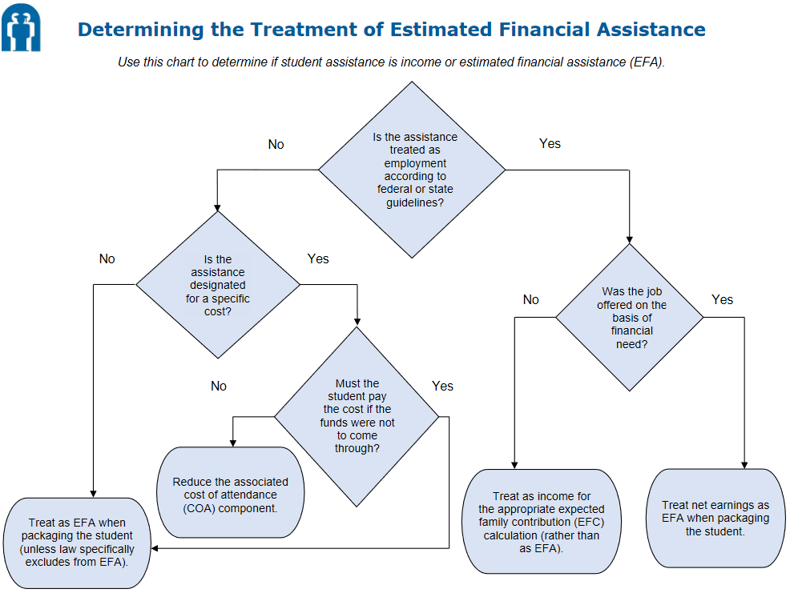

AskRegs Q&As represent NASFAA's understanding of regulatory and compliance issues. They are FOR INTERNAL USE ONLY. While NASFAA believes AskRegs Q&As are accurate and factual, they have not been reviewed or approved by the U.S. Department of Education (ED). If you should need written confirmation of AskRegs information for audit or program review purposes, please contact your ED School Participation Division. NASFAA shall not be liable for technical or editorial errors or omissions contained herein; nor for incidental or consequential damages resulting from the furnishing, performance, or use of this material.

