Graduate Staff Internship Program

Appointment Processing Fiscal Year 2025

Graduate Staff Internships serve as an employment opportunity for eligible graduate students that will allow students an opportunity to explore a professional role in higher education, that of administrative service. Students are supervised by a professional staff member in one of the Student Affairs or Enrollment departments, and will perform professional tasks, either in a programmatic area or in a service role. These tasks are not primarily clerical in nature, although some clerical tasks may be included; staff interns may design programs, lead or direct undergraduate students in programs; carry out administrative tasks such as assessment, case management, responding to external constituents on behalf of a program or office, or process complex paperwork or files under the supervision of a professional employee. Students will have supervised decision-making power and will be given the opportunity to interpret and enact institutional policies.

Internships are managed by the Provost’s Office and allow Student Affairs and Enrollment the ability to offer a unique program with a Higher Education Administration focus. Tuition waivers, not to exceed a total of thirty (30) waivers each academic year, are awarded by the Provost’s Office as part of the compensation for these positions. Graduate Staff Internships will be offered to those students who show a financial need and meet work-study eligibility requirements.

Contents
- Eligible Departments 2
- Position Allocations 2
- Recruitment 2
- Eligibility 2
- Workday Appointments 3
- Waivers 4
- Graduate Student Medical Plan 5
- Payroll 5
- Evaluation and Certification of Effort 5
- Services Required 6
- Leave and Vacations 6

APPOINTMENT OF GRADUATE STAFF INTERNSHIPS

Eligible Departments
The following departments and their affiliated units under the Provost’s Office and Enrollment are eligible to request a Graduate Staff Internship position. Any other graduate student positions, including assistantships, that these units may fund, are not part of this program and are to be administered separately.

Provost’s Office
Academic Success and Career Center

Enrollment
Admissions
Orientation and Transition Programs
Enrollment and Recruitment
Office of the Registrar
Student Financial Services
Enrollment Information Technology

- Position Allocations
Departmental needs will be considered when Enrollment area administrators review any requests for internship positions each fiscal year. Area administrators will evaluate department’s requests, job descriptions, and consider how closely the positions link to the core of the Graduate Staff Internship program.

- Recruitment
Once Enrollment area administrators have determined that a department is to be allocated an internship position, departments will be responsible for the advertising and recruitment to fill open positions.

Departments must hire by August 16th, the start of the academic term. There will be a 5-day grace period, 1st week of classes, for extenuating circumstances only. Any extenuating circumstance would require approval by the Provost Office.

Departments will need to use the offer letter templates from the portal site. The offer letter should be printed on departmental letterhead and the language in red should be reviewed carefully and adjusted to fit the department’s appointment details.

Washington State University is an equal opportunity employer committed to providing equal opportunity to applicants and employees without regard to race/ethnicity, creed, color, national origin, religion, gender, sexual orientation, age, marital status, the presence of any sensory, mental or physical disability, use of a trained guide dog or service animal by a disabled person, disabled veteran or Vietnam-era veteran status.
WSU has made, and will continue to make, every effort to eliminate barriers to equal opportunity available to underutilized groups.

- Eligibility
The eligibility for graduate students to be considered for an internship will be reviewed by Michelle Ellinwood with Student Financial Services.

Departmental administrators that are processing GSI hires, can follow the link below to the SMARTSHEET used to track the hiring and awarding of Graduate Student Interns.
Grad Student Intern Assignments & Processing

Eligibility & Awarding:

An internship offer will only be extended to those that are determined eligible based upon their financial aid package, which includes:

FAFSA, scholarships received and immediate residency in the State of Washington upon the appointment start date.

Eligibility room in package for full work-study award ($15,880.80). GSI receiving other eligibility from other tuition & fee’s wavier would be reduced. It would be up to the discretion of the department to pay the difference.

  - For an initial internship appointment, admission to the Graduate School to GRADUATE status is required.

  - Only students admitted to a graduate career on the Pullman or urban campuses are eligible for internships. Students admitted to a graduate career through Global Campus (campus status code OLIN) are not eligible for internships. Students admitted in status codes of NADC and UNDG are not eligible for internships; they must be in a degree seeking status.

  - Only students who are an established State of Washington resident by the first date of
their appointments are eligible for internships.
- The graduate student’s financial need must remain unchanged as demonstrated on the FAFSA during the period of their appointment, and they must be free from educational loan defaults.

- Mandatory employee training on the Responsible Conduct of Research will be required of all graduate students. This is a web-based training located at myResearch.wsu.edu. Students are encouraged to take this training as soon as possible. The training needs to be repeated after a five-year period. Students are not eligible for an internship until after the training is completed unless otherwise noted.

- Mandatory employee training on Discrimination and Sexual Harassment Prevention is required of all graduate students on internships. This is a web-based training, and All WSU employees (including students, temp hourly, and graduate students) must complete the DSHP course within the first six months of hire, and annually thereafter. New employees receive access to their online learning account after their hire action is successfully completed within Workday. Access Skillsoft Percipio, WSU’s learning management system, here https://wsu.percipio.com/ to compete all mandatory training.

- Failure to fully complete this training may result in future ineligibility of any financial support or benefit of appointment. All employees are required to repeat this training every five years from the date of initial training. Questions regarding this training may be directed at Human Resources Services at hrstraining@wsu.edu. Questions about sexual harassment or discrimination can be directed to the Office of Compliance and Civil Rights at 509-335-8288 or ccr@wsu.edu.

- Graduate students must maintain a 3.0 cumulative GPA during the period of their appointment and the progress towards their degree must remain satisfactory as determined by their academic home department. It is the departments’ responsibility to monitor the GPA.

- Graduate students must enroll in a minimum of 10 credit hours and be considered full time during the period of their appointment PEACT & Audit courses are exempt. It is the departments’ responsibility to monitor the credit hours.

- Appointments

  - Once the Enrollment area administrators have determined that a department is to be allocated an internship position, and the department has confirmed the student meets all eligibility requirements, the department head may proceed unofficially to offer the student a graduate internship appointment, subject ultimately to administrative approval.

  - When making unofficial offers, care should be exercised to stipulate the correct rate of pay and terms of appointment. When making an internship offer, please use the template offer letters that are provided on the portal site as they are specific to these internship appointments. Please retain these offer letters in accordance with the WSU Records and Retention schedule.

  - Graduate Staff Intern Appointments are processed in the Workday system as student hourly appointments. These appointments use the following position restrictions and compensation:

Business Title: Graduate Staff Intern

Job Profile: 9962-YN_STUDENT - Graduate Staff Intern

Job Family: Student > Student Hourly

Employee Type: Student Hourly (+) (Fixed Term)

Compensation Package: Hourly Package

Grade: Graduate Staff Intern

This Reference Guide provides information on how to create student hourly positions in Workday.
https://jira.esg.wsu.edu/servicedesk/customer/kb/view/156963523

  - Graduate assistantship appointments are typically half‐time or .50 FTE (20 hours/week). Compensation ranges from step 59 to 130. Minimum compensation steps are based on location and program level. Further assistantship salary information can be found in Article 35 of the WSU/UAW contract: https://hrs.wsu.edu/employees/labor‐relations/collective‐bargaining/wsu‐uaw/wsu‐uaw‐contract‐2024‐2026/#ARTICLE‐35.

If a department chooses to pay a higher hourly rate, they may do so with the understanding that their departmental funds will be used to cover this additional amount.

Minimum Hourly Wage Equivalency for Graduate Student Employees in Hourly Appointments:
Academic Student Employees are paid hourly rates based on their working hours at half of the full-time equivalent (FTE). In the state of Washington, a full-time job for 12 months is equivalent to 2,088 hours per year, which is equal to 174 hours per month. Since Academic Student Employees work at a .5 FTE, their work hours are half of this full-time monthly total, resulting in 87 hours per month (174 divided by 2). The monthly salary figures provided in this context are based on these 87 hours.

ASSISTANTSHIP SALARY TABLE Effective 05/01/2024
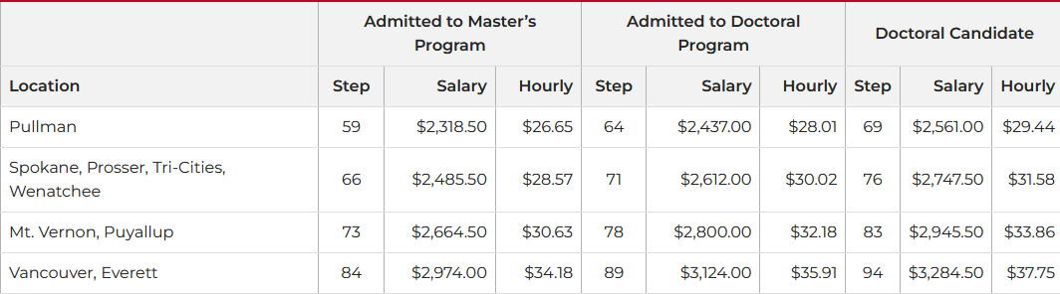

  - Temporary hourly employees accrue paid sick leave (PSL) for all hours worked, including overtime, in accordance with RCW 49.46.200 and WAC 296-128-620.
For purposes of this policy, temporary hourly employees are non-student, student, and work-study employees. The calendar year is January 1 through December 31.
For more information please visit:
Paid Sick Leave for Temporary Hourly Employees

  - For academic year 2024-25, departments cover 40% of wages for these positions. Please monitor work-study appointments to make sure the allotted work study amount is not overspent.
Departments can monitor work-study payroll transactions using the following Workday report:
CR PAY Work-Study Payroll Transactions

  - The WSU Grad School’s Graduate Appointment Processing Memo is for all graduate assistantship appointments from August 16 through May 15. The Waiver Acronyms Memo offers a list of waiver acronyms options, their associated names, and allowable Fund and Job Classes.

- Waivers
  - Upon approval of internship appointment, the Provost Tuition Waiver will be posted by Student Financial Services to the student's account. If unable to complete the term of their employment, the tuition waiver award will be pro-rated the same way that the institution manages tuition refunds.

Waiver Cancellation Schedule:
Week Appointment Discontinued | 1 | 2 | 3 | 4 | 5 | 6 | 7 | 8 | 9 | 10+
Percentage of Waiver Cancelled | 100 | 80 | 80 | 70 | 60 | 60 | 50 | 50 | 40 | 30

After the tenth week of the semester, if a student is dismissed due to not meeting the duties and responsibilities of the internship, 30% of the tuition waiver will be cancelled.

If a student or department wishes to appeal against the cancellation of the waiver, they may submit a petition to appeal to the Unit Liaison. The appeal will be reviewed by a designated Appeal Committee, decision rendered and relayed to the student/department. Current Appeals Committee members are Michelle Ellinwood, Joy Scourey & Don Holbrook.

Waivers do not cover mandatory graduate student fees. Graduate students on an internship will be responsible to pay the mandatory student fees each semester, as well as a small portion of the tuition that cannot, by law, be waived, estimated at $1,000/semester.

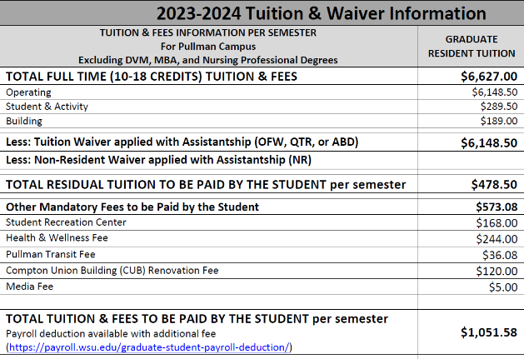

Further, to qualify for the waiver(s), the student must reside within the State of Washington (RCW 28B.15.014).

  - Students who cancel their enrollment after the semester has started will have those tuition charges reduced based upon the institutional policy. For more information regarding this policy, please visit the following website: https://registrar.wsu.edu/tuition-adjustments/.

- Graduate Student Medical Plan
Graduate students on an internship appointment have the option to purchase the Graduate Student Health Insurance Medical Plan at their own expense. It is designed to help students pay a portion of the medical and dental expenses they may incur (see https://cougarhealth.wsu.edu/studentinsurance/graduate-students/ for plan benefits, claims and card information). Students on appointment for the academic year and/or spring semester will be automatically covered throughout the summer. The comprehensive health insurance program offers spouse and dependent coverage at an additional cost to you if you choose these options. Contact Health & Wellness Services for further details.

Students on an internship are NOT automatically enrolled in the health insurance. If you would like to purchase health insurance, please send an email with your request to enroll to student.insurance@wsu.edu) by the 13th day of classes and note that you are on a Graduate Staff Internship appointment.

- Payroll
Departments are responsible for ensuring the Graduate Staff Interns’ appointments are set up using the correct accounting for the 60/40 split. The Departments also need to make sure the students’ hours are recorded on time each pay period. If you have any questions, you can reach out to Stephanie Alvarado (stephanie.alvarado@wsu.edu) in Student Financial Services.
.
- Evaluation and Effort Certification
This is the supervisor’s responsibility and not Student Financial Services.

If a graduate student is appointed to a Graduate Staff Internship position for a semester, or for the entire academic year, the department is responsible for ensuring that the student receives a review of their progress in fulfilling the responsibilities of the internship. In addition, all students appointed to an internship must certify annually that they have met the requirements of the internship. Effort Certification requires both the student’s and the department/supervisor’s signature indicating that the student did all of the following during their appointment period:
- Remained enrolled full time (at least 10 credits during the fall and spring semesters);
- Maintained a 3.0 cumulative GPA during the period of the appointment; and
- Met the service requirement of an average of 20 hours per week as schedule by the department/supervisor.
If the student did not meet one or more of these requirements, the student will not be eligible for reappointment to an internship, unless he/she is granted an exception to the policy based on extenuating circumstances. Exception to this policy must be submitted by the student to the Provost’s Office.

GSI Services Required
  - Internship appointments require an average of 20 hours of work per week during the term of the appointment.

  - It is the departmental supervisor’s responsibility to meet with the student employee on or before the first day of their appointment to establish a satisfactory work schedule that meets this requirement.

- Leave and Vacations
  - Graduate Staff Interns on appointment do not earn annual leave.
  - Sick leave accrual is based on I-1433 per university policy for hourly employees.

