Washington State University
Policies the Treatment of Other Financial Assistance & Reporting Payments/ Reimbursements to Students, Not Processed through SFS

Rules on the Treatment of Other Financial Assistance (OFA)

Resources provided beyond federal, state, institutional financial aid and scholarships, grants, and net earnings from need-based employment or loans are considered educational benefits provided because of enrollment as a student as WSU. These benefits are counted in a student’s financial aid eligibility. Gift cards and prizes awarded to a student based on their enrollment status are also considered OFA and must be reported to Student Financial Services. All resources provided to the student must be reported to Student Financial Services to assess and determine how such funding should be accounted for and processed if awarded by the institution. Whether the award or benefit is taxed or untaxed does not affect whether it is used as OFA in the student’s package.

If a student receives an award or benefit during a period of nonattendance, and these funds are provided to the student due to postsecondary enrollment, then those funds are OFA towards the upcoming period of enrollment. For example, the student is not enrolled for the summer but receives grant funds to cover summer housing, those funds are OFA towards the upcoming period of enrollment (not for summer). No exceptions

Per federal rules, there is no de minimis or minimum amount that would not have to be reported to Student Financial Services (SFS).

If a department wants to know what the impact will be to a student’s financial aid prior to processing a reimbursement, they can email sfs.compliance@wsu.edu requesting a review.

Short term emergency loans and earnings from work that are not based upon financial need are specifically excluded from consideration as OFA.

Accounting for Other Financial Assistance That Does Not Disburse through SFS

Funding sources that are considered OFA and do not disburse through SFS are accounted for as “Placeholder” funds on a student’s financial aid account. If funds are disbursed directly by the Bursar’s Office, SFS will receive notification from Bursar’s Office to account for these funds. SFS projects the same amount of funding will be applied to spring term to assist with ensuring no future over award. If a student is not receiving funds for a future term, they can contact SFS and the projected funding will be removed. Common funding sources accounted for this way are Departmental guarantees such as Fellowships or Assistantships, and Outside Third Party Guarantees such as State Veterans Waivers, Employer reimbursement of employee’s tuition and Vocational Rehab Guarantees.

Reporting Student Reimbursements Processed Through Workday

Reimbursements being processed through Workday will be identified through reports ran by SFS. In Peoplesoft (myWSU), SFS will account for the funding on the student’s financial aid account as a placeholder award and will add a comment on their file of what the reimbursement is for. The student will also receive an email notification that the funds have been accounted for and if any adjustment has been made to their financial aid package.

Reporting Student Reimbursements Not Processed through Workday, Bursar’s or SFS

To report a student reimbursement or a list of student reimbursements such as a gift card or cash prize, please submit through this Smartsheet Form.

Student Financial Services Processing
SFS will account for the funding on the student’s financial aid account as a placeholder award and will add a comment on their file of what the reimbursement is for. The student will also receive an email notification that the funds have been accounted for and if any adjustment has been made to their financial aid package.

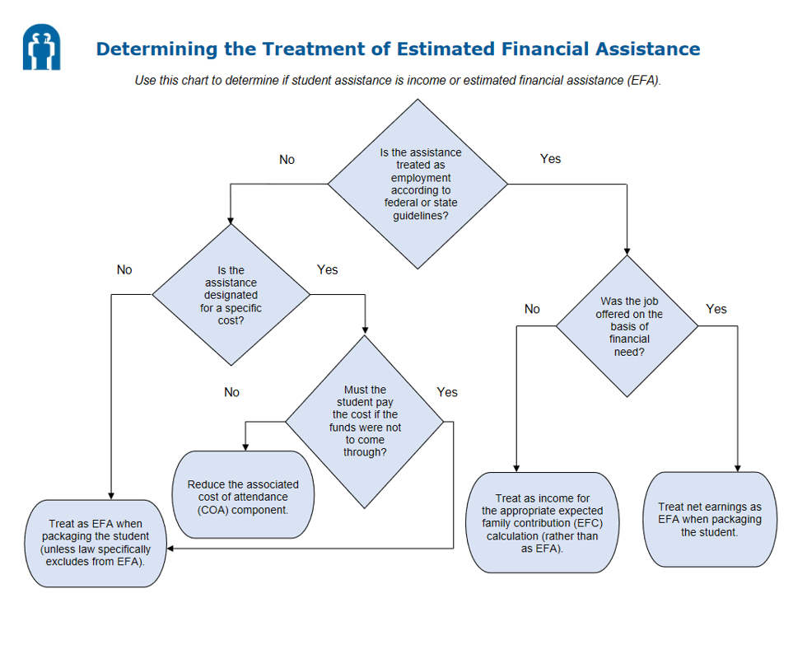
Note that effective 2024-25, Estimated Financial Assistance (EFA) is now called Other Financial Assistance (OFA). Funding that is considered Emergency aid still needs to be accounted for and may not count towards the students need per federal regulations.

