SARAS Departmental Waivers
What are we doing?
When a department would like to award a student a waiver, they can submit a SARAS record through to Student Financial Services. The SARAS record is used to manually process a waiver and have it posted on the student’s financial aid package.
Where do we do it?
We do this within the SARAS database.
Navigation: sfspartners.wsu.edu > SARAS > Enter Waiver Authorizations
How do we do it?

- You’ll want to go to the SFS Partner Portal website: sfspartners.wsu.edu
- Here is a screenshot of the SFS Partner Portal landing page:
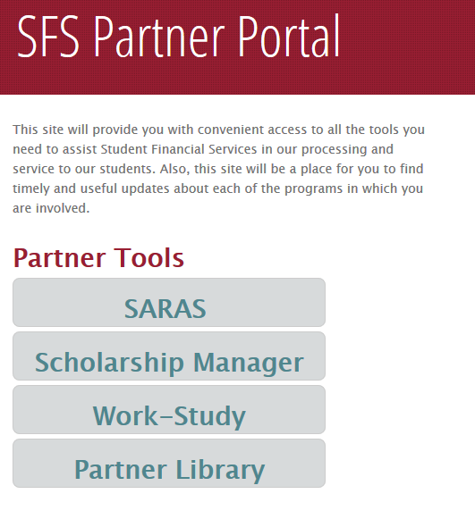
- Click on the SARAS option to bring you to the SARAS database.

- You will be prompted to log in using your WSU Network ID and password.

- Next, you’ll come to the SARAS landing page. This will present two database options; you’ll want to select the Enter Waiver Authorizations database.
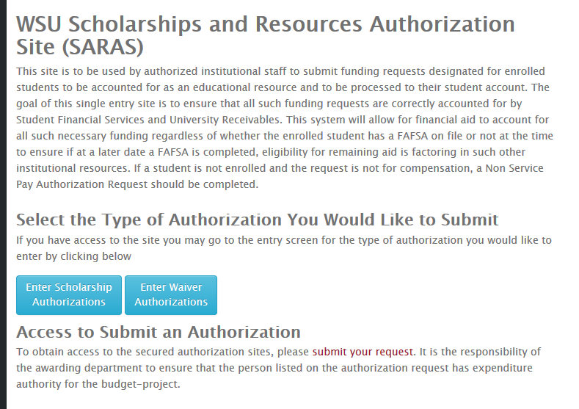

- Once you are logged in, you should see the homepage screen for departmental waiver authorizations. Here you will be able to create and submit a record, edit a previously submitted record, and look at the history of previously submitted records.

Submitting a New Waiver
- Select the NEW option to enter a new waiver.
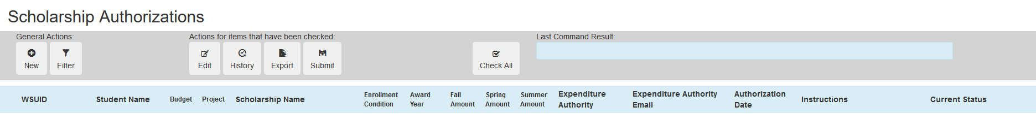
- When entering a new record, you will want to enter the student’s ID Number and hit tab which will autofill the student’s name.

- Next, enter the Item Type of waiver you are submitting. Once you do this, click the drop down arrow in the Waiver Name box to select your waiver.

- Please note that if the name of the waiver does not appear, then you may need to request a new item type by pushing the blue “Request New Item Type” button.

- Continue to fill out the required information and then select either Save, which will save and bring you back to the queue, or select Save & Continue to enter another waiver.

- Once you’ve entered all the waivers you want to submit, you’ll be brought back to the main Waiver Authorizations page. Click the boxes next to the waiver re cords then select Submit. This will then send the waiver records to SFS for processing.

Editing or cancelling an already submitted record
If a student’s award needs to be changed or cancelled, you will submit an “edit” to the waiver record. This is completed from the Waiver Authorizations page.
- On the far left side of the screen, next to the student’s waiver record, you will see a checkbox; use this checkbox to select the award you want to edit, then select the Edit.
- Once you have completed the edit, click Save to save the changes. There is no need to submit the record again; the Save option in this case, sends an updated record to SFS for processing.

