1. **Step 1, Log In:** log in to Work-Study Section of Partner Portal. When Employers navigate to the SFS Partner Portal, [sfspartners.wsu.edu](http://sfspartners.wsu.edu/), they will see the following screen, and need to select the Work-Study button. 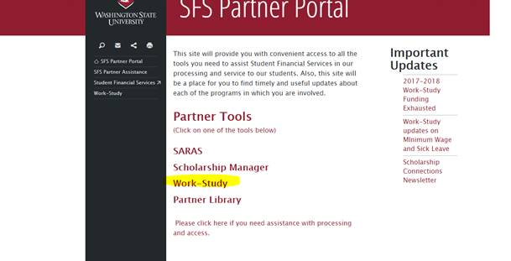
2. This will prompt the employer to log in using their WSU Network ID and Password

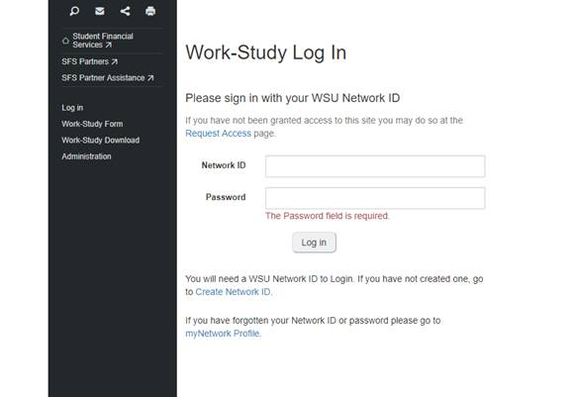

1. Select “work-study authorization form” on the grey, left hand menu and then enter the student’s ID and select :Verify work-study availability for student”

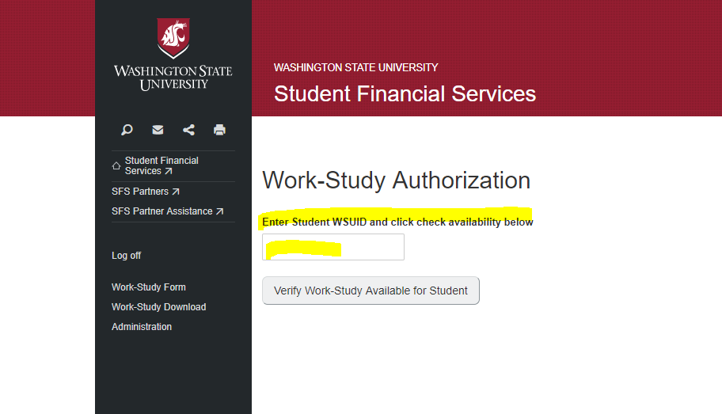

1. If the student has work-study eligibility, the page will change to the work-study authorization form pre-filled with their information and the student's information.

If the following message appears, *Student not found. Please request that student email Student Financial Services at*[*sfs.workstudy@wsu.edu*](mailto:sfs.workstudy@wsu.edu)*,* then they are not work-study eligible. If this seems incorrect, please see w/s FAQ on the Partner Portal and/or contact us at [sfs.workstudy@wsu.edu](mailto:sfs.workstudy@wsu.edu) to troubleshoot

1. Employers need to fill in the blanks, check the “I agree” box at the bottom, and select "Create Authorization". They will receive a confirmation message that the form has been submitted, and both the person filling out the form and the authorizing signature will receive email confirmation. The WSAF is only available electronically. Once the form has been filled-out, the form will go to the specific campus the student is attending.

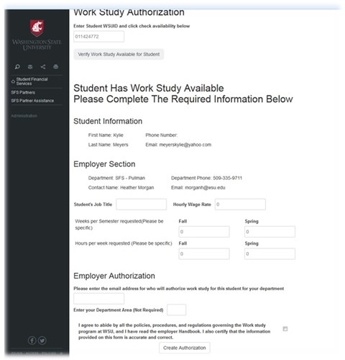

1. Troubleshooting:

* The Hourly Wage **x** Total # of Wks **x** Total Hrs **x** 2 Semesters **CANNOT** exceed $4,000 (the maximum work-study amount). If it does, the following message will appear: *"You have exceeded the $4,000 maximum award amount for Work-Study, please adjust the hours, weeks or wage below to keep the total award within this limit". Cannot exceed $2000 per semester*
* There is contact information for processing, access and technical assistance list on the SFS Partner Portal homepage, under "Please Click if you need assistance"

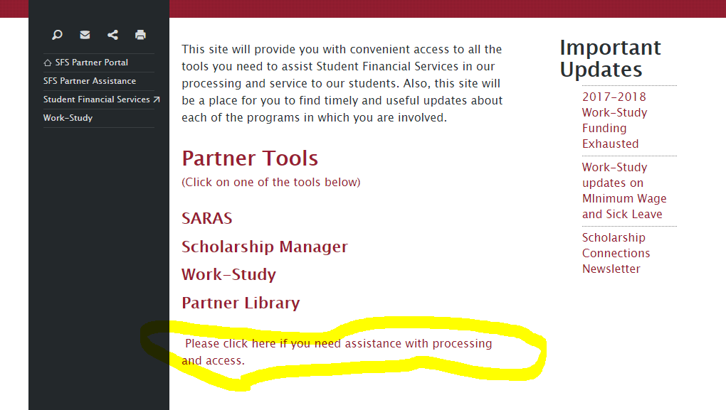

**Step 7: Awarding**: Once the WSAF has been processed, the student the award will be processed. This can take up to 3 to 5 business days to process. Students and employers will be notified by the work-study employer coordinator Students should not start work until they have received an email from our office notifying whether they have been awarded work-study. If a student does start work before receiving a confirmation notification, then the employer may not receive Work-Study funds to cover those wages.

**QUESTIONS?**

**Pullman and Everett Contact** — Student Financial Services; email: [sfs.workstudy@wsu.edu](mailto:sfs.workstudy@wsu.edu); phone: (509) 335-9711; Lighty Student Services Building, Rm. 380

**Pullman Contact** — Student Financial Services; email: [sfs.workstudy@wsu.edu](mailto:sfs.workstudy@wsu.edu); phone: (509) 335-9711; Lighty Student Services Building, Rm. 380  
**Tri-Cities Contact** — Student Financial Services; email: [tricities.financialaid@wsu.edu](mailto:tricities.financialaid@wsu.edu); phone: (509) 372-7228; Student Financial Services, West Building, Rm. 269  
**Vancouver Contact** — Cougar Center; email:van.finaid@wsu.edu; phone: (360) 546-9559; Student Services Building (VSSC)  
**Spokane Contact** — Academic Center; email:[spokane.financialaid@wsu.edu](mailto:spokane.financialaid@wsu.edu); phone: (509) 358-7534; Academic Center, Rm. 130