SARAS Procedures for Departments
Washington State University Student Financial Services
Tel 509-335-9711  Fax 509-335-1385 | P.O. Box 641068  Pullman, WA 99164 | www.financialaid.wsu.edu  financialaid@wsu.edu

Contents
SARAS Procedures 1
Where do we do it? 1
Expert Staff 1
How do we do it? 1
Navigating in the Partner Portal 1
Submitting a New Scholarship Authorization 3
Finding your Scholarship Authorizations 4
Information about the SARAS authorization 5
Revisions from SFS 8
Editing or cancelling an already submitted authorization 9
Things to know 10
Summer Awards 10

SARAS Procedures
When a department would like to award a student a scholarship, they can submit a SARAS authorization through to Student Financial Services. The SARAS authorization is used to manually process a scholarship, and have it placed on the student’s financial aid package.

Where do we do it?
SARAS – SFSpartners.wsu.edu -> SARAS -> Scholarship Authorizations
The procedures for scholarships and waivers are nearly identical. This procedure will cover Scholarship Authorizations.

Expert Staff
Tara Williams – Financial Aid Advisor
Heather Morgan – Assistant Director of Scholarship Administration

How do we do it?

Navigating in the Partner Portal
- Below is a screen shot of the first screen in the SFS Partner Portal. SARAS is the first button under the “Partner Tools.” That is where you will want to go in order to log in.
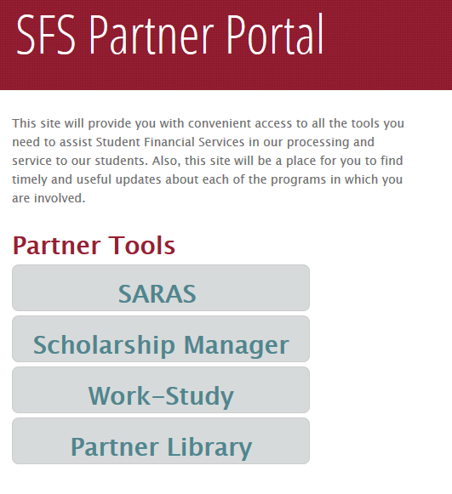

- This is the SARAS home page. Here you can request access to the SARAS application and access the Departmental Scholarships Authorization page and the Waivers Authorization page.

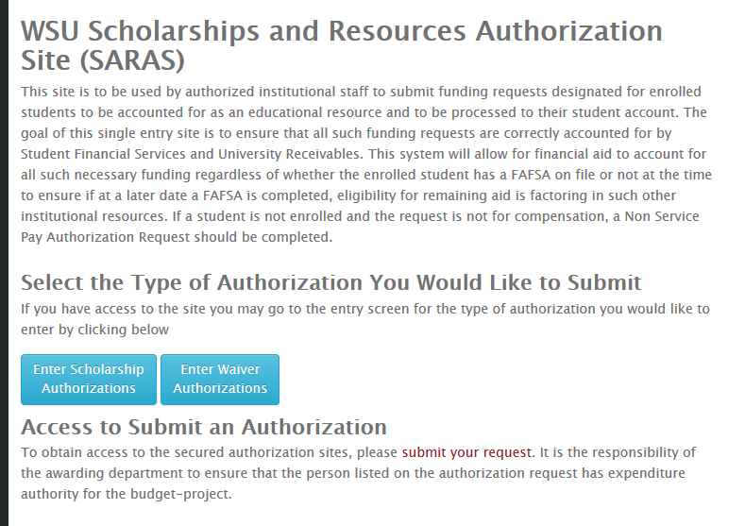

- After selecting which Authorization type you would like to work with, a log in screen will appear. You will use your network ID and password. Once you have logged in, you will see the “Administration” page, where you can select “Enter Departmental Scholarship Authorizations”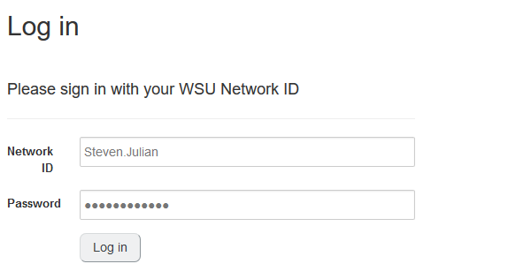

- Once you are logged in, you should see the home screen for departmental scholarship authorizations. Here you will be able to create and submit an authorization, edit a previously submitted authorization, and look at the history of previously submitted authorizations.
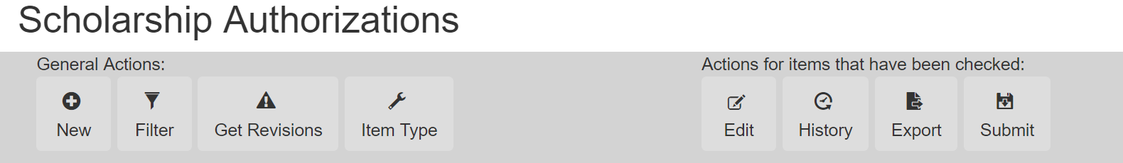

Submitting a New Scholarship Authorization
Each departmental user can submit one SARAS authorization, for each award, for an aid year, for an individual student. Once an authorization is submitted, you will need to submit a change to the authorization to update it.
- When entering a new authorization, you will want to enter the student’s ID Number and hit tab to recall the student’s information.
- After you enter the budget and project numbers, the scholarship name should appear in the drop down menu. Please note that if the name of the scholarship does not appear, then you may need to request a new item type by pushing the “Request new item type” button. This will take you to a new screen, so please make sure your pop up blocker is not preventing it from opening.
- Continue to fill out the required information providing information for what enrollment status is required for the scholarship, which aid year and term the money should be disbursed to.
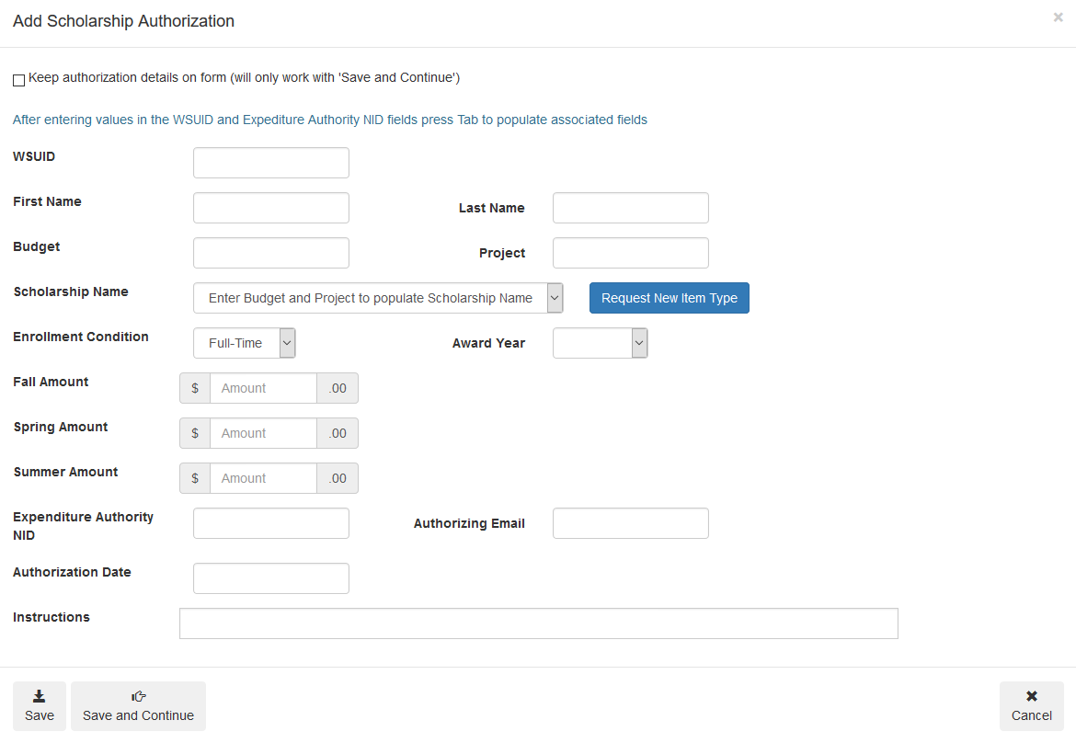
- After you have input the data, the authorization is saved in a created status. It will need to be “submitted” to Student Financial Services, or else it will not be processed.
- To submit the record, you will need to select the check box of an authorization in a “created” or “revised” status. After checking the box(es) for the authorizations you would like to submit, you will then click the submit button found at the top row of SARAS.
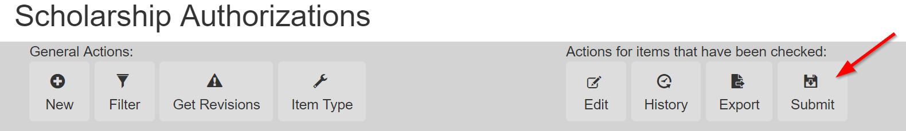

Finding your Scholarship Authorizations
- In order to make an edit, or to view the history on your award, you need to locate the award. Currently when you log in, all of the scholarship authorizations you have entered will appear. You can sort through these by using the filters located in the top buttons.
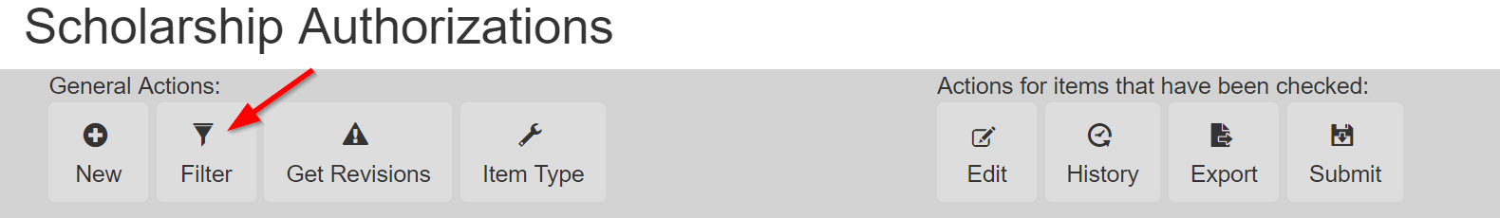
- The screen that pops up next will allow you to filter by status, award year, WSU ID or the budget and project of the awards.
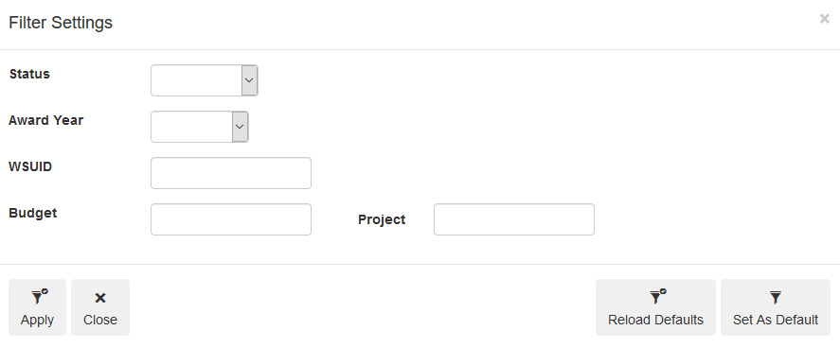

Information about the SARAS authorization
- Vocabulary –
 | Status
Created | This means your authorization was created and is ready to be sent to SFS but has not been submitted.
Submitted | SFS has received your scholarship authorization but has not processed it yet.
Posted | The scholarship authorization has been processed by SFS.
Revised | SFS has returned your scholarship authorization for a clarification. This authorization will need to be re-submitted to SFS.

 | Enrollment Conditions
Any | The student must be enrolled in at least 1 credit, unless otherwise noted in the “instructions section”
Part-time | Student needs to be enrolled in at least 6 credits to receive the scholarship.
Full-time | Student needs to be enrolled in at least 12 credits to receive the scholarship.

  - Authorization date – This the day the authorization was originated. If the authorization date is manually changed when the authorization is created, then this is the day the system will deliver the scholarship authorization to SFS

  - Status Date – This is the day the status of the scholarship authorization was last changed. This can happen when an award is submitted, posted, or revised.
  - Instructions – The instructions section of the scholarship authorization is a place for the departmental user to put notes.

- History

  - Navigation – Once you have found the scholarship authorization you want to view the history on, you can select the checkbox to the left of the authorization and then select “history” in the top buttons.
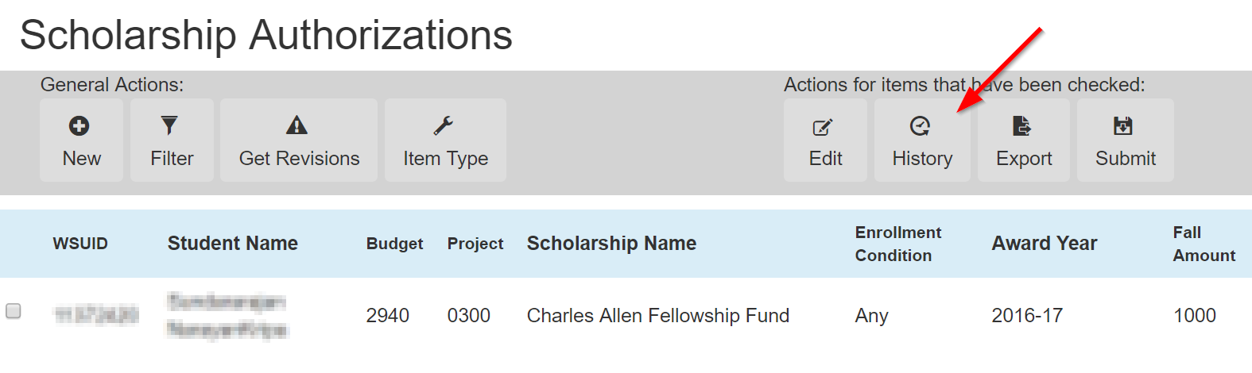
  - What to look for – Any edits you make will show up as a new line in the history box. You will want to look at the status date for an understanding of when it was last touched.
Below, we can see there was an edit was made to this scholarship authorization on October 25th. An edit does not change the status, so it will continue to read as “posted” but SFS will need to “post” the award again to remove it from their queue. On November 1, this award was “posted” again.
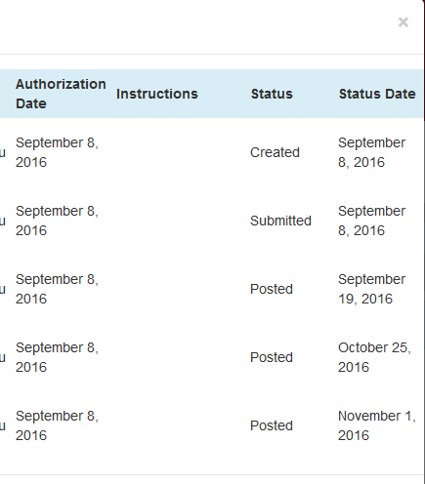

Revisions from SFS
You will receive an email notification if a Scholarship Authorization is sent back to you with a request for a change or a clarification. When you log into SARAS and have revisions, you will also see a notification pop up when you open your Scholarship Authorizations page:
“You have authorization(s) that require a revision and need to be re-submitted. Use the 'Get Revisions' button to view these authorization(s). The 'Counselor Notes' field should contain instructions for what needs to be changed. After completing revisions you must re-submit these authorizations to be processed. After all revisions have been made, you may return to your normal filter view by selecting the 'Filter' button then choose 'Re-load Defaults'.”
- If you want to “Get Revisions” to look at the scholarship authorizations that were submitted back to you,you can click “get revisions” or filter by the revised status. If you wish to remove all filters, please click reload defaults.
- You will need to look at the “counselor notes” to determine what the clarification is. Examples of this could be to put a note regarding the enrollment condition, or moving the award to a different term.
- Once you have completed the changes, you HAVE TO submit the scholarship authorization back to Student Financial Services.

Editing or cancelling an already submitted authorization
If a student’s award needs to be changed or cancelled and you as the user are initiating these changes, then you will submit an “edit” to the scholarship authorization. This is completed from the Scholarship Authorizations page.
- On the far left side of the screen, you will see a checkbox; use this checkbox to select the award you want to edit, then press the edit button.
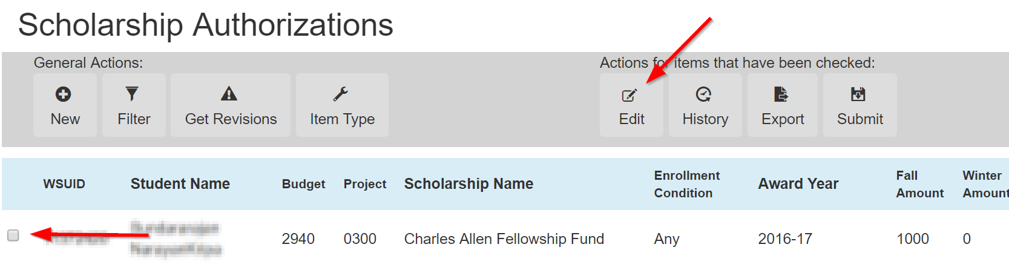
- Once you have completed the edit, you will save the changes. You do not need to “submit” the changes to the authorization because a save will automatically submit the authorization change to SFS.
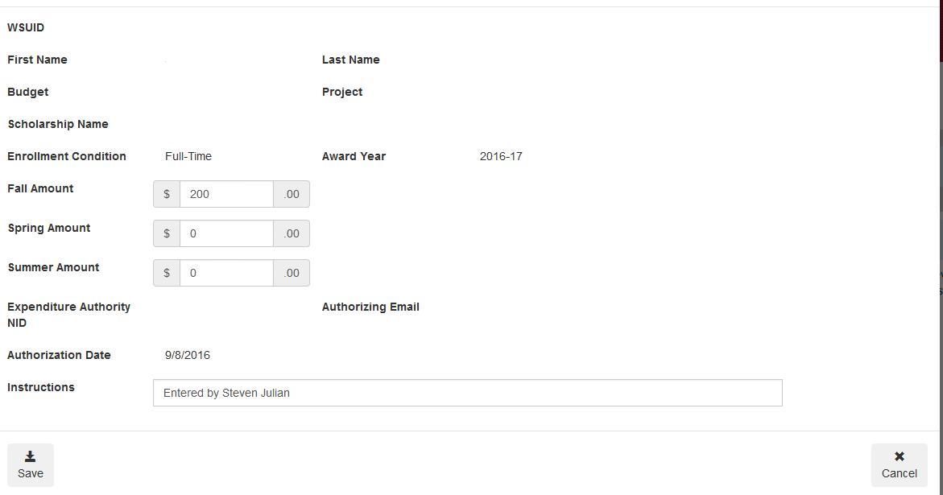
- A change to an authorization that was not a revision does not need to be re-submitted. A save will generate a notification for Student Financial Services.

Requesting a new Item Type and changing Item Types
If you need to request a new Item Type or request a change to an existing Item Type select the Item Type button. If you are in the process of creating a new authorization there are buttons on the New Authorization form for creating and editing item types as well.
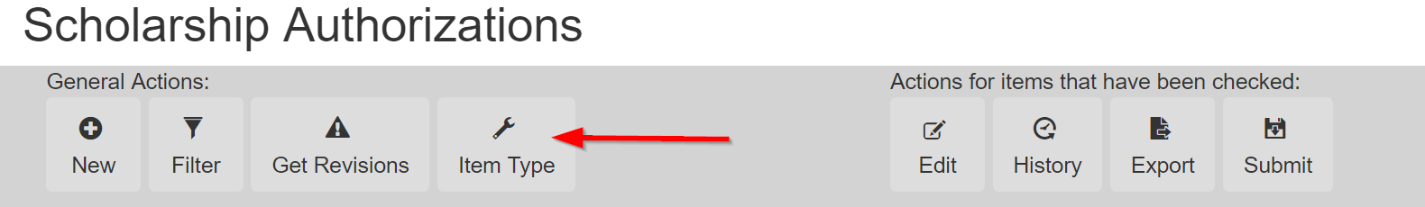
- Selecting New Item Type will open a form on a new page. Complete the information on this form and select Request Item Type. The information you entered is sent to the Office of Scholarships along with your login Information as the requestor.
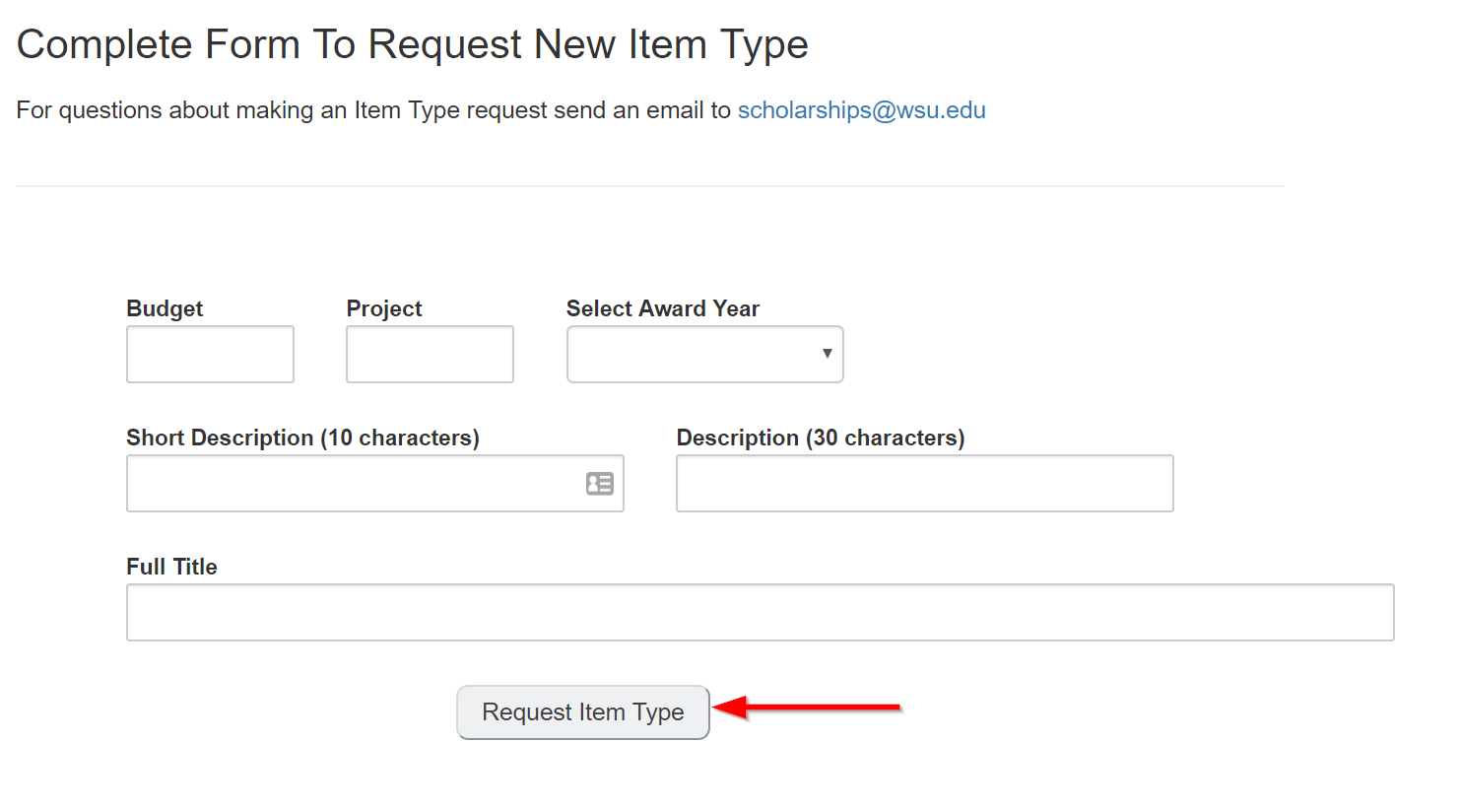

- Selecting Edit Item Type will open a form on a new page. On this page, you will first need to enter the Item Type or the Budget and Project associated with the Item Type you would like to edit then select Lookup Item Type.
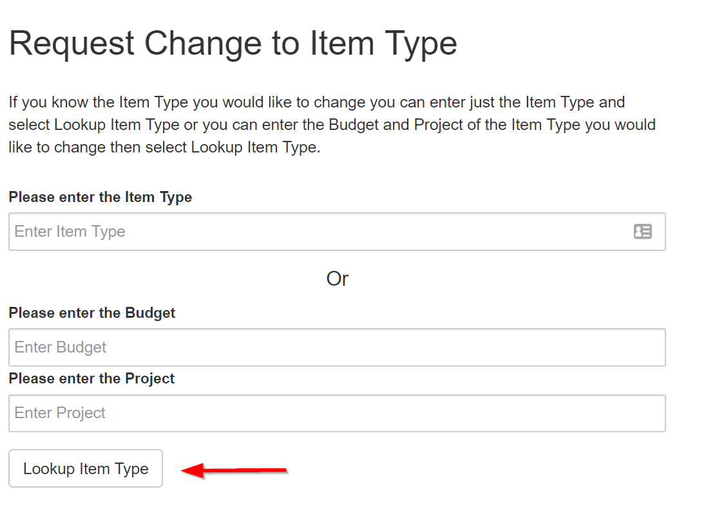
If there is more than one Item Type that matches you will receive a drop down menu to select the Item Type to edit then choose Select Item Type to proceed.
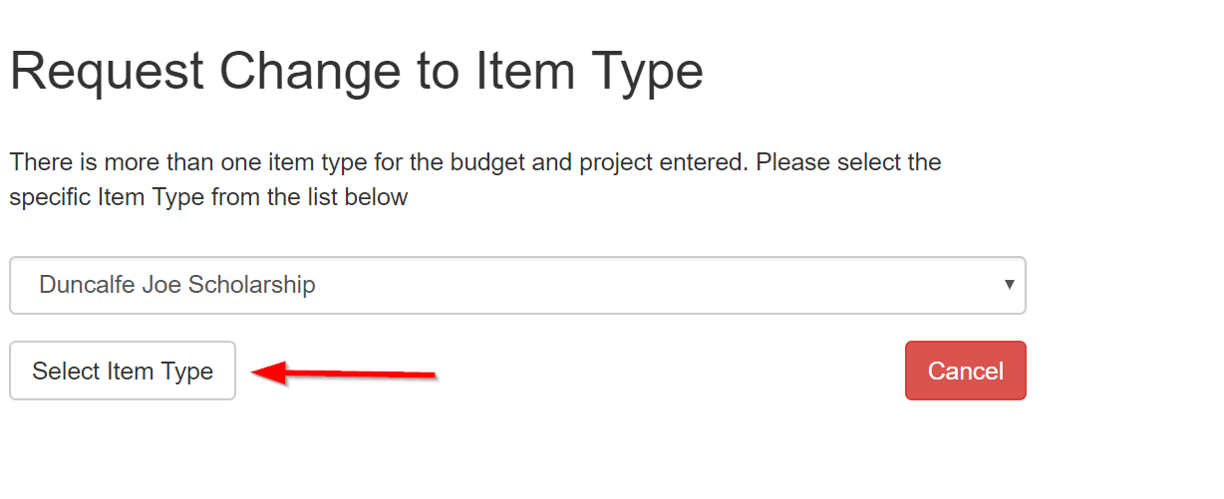
Next the item type you have selected will be displayed and a form presented to make changes to either the Title, Budget or Project. Select Submit to send your change request.
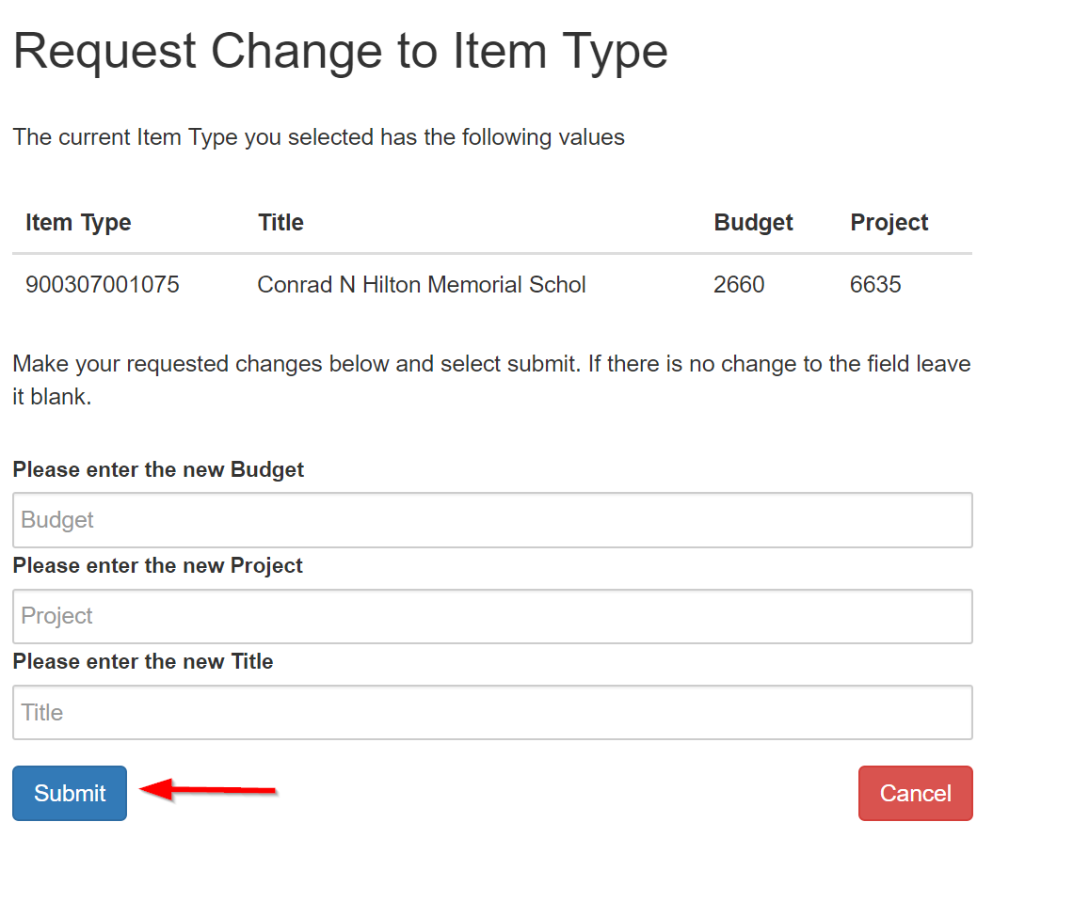

Things to know
If a student is already fully awarded up to their cost of attendance, and you submit a scholarship for them, it is highly likely that the scholarship will reduce the student’s financial aid package.
Each student can only have one SARAS , for each award, being submitted from an individual departmental user. Once an authorization is submitted, you will need to submit a change to the authorization to update it.

Summer Awards
- Summer is a trailing term for our academic year.
- Full time during the summer is considered at 6 credits.
  - For ease, please use the instructions section to identify if there is a credit requirement for students who are being submitted through as “part time.”
- If a student does not need to be enrolled to receive the funds, please identify that though the instructions section as well.

