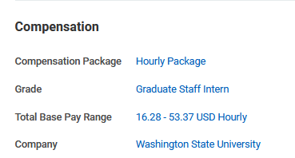
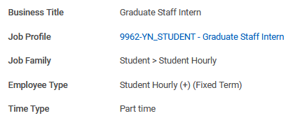

Graduate Staff Intern Appointments are processed in the Workday system as student hourly appointments. These appointments use the following position restrictions and compensation:
Business Title: Graduate Staff Intern
Job Profile: 9962-YN_STUDENT - Graduate Staff Intern
Job Family: Student > Student Hourly
Employee Type: Student Hourly (+) (Fixed Term)
Compensation Package: Hourly Package
Grade: Graduate Staff Intern

This Reference Guide provides information on how to create student hourly positions in Workday. https://jira.esg.wsu.edu/servicedesk/customer/kb/view/156963523
All time for work study and departmental appointments will be entered/reported in Workday.
Temporary employees’ effort is recorded in the Workday Enter and Correct Time business processes.
See the Workday Enter and Correct Time reference guide here.

ALL GSI Appointments are partially funded by State Work-Study once approved:
GSI Appointments MUST be assigned Work-Study compensation as part of the requirements of this position. Please follow standard protocol for assigning State Work-Study to the student compensation.
Based on Washington State University (WSU) student employment guidelines, state work-study positions are often linked to specific civil service titles for pay equity. While specific, changing "R" codes (such as R034, etc.) are used for SWS (State Work-Study) compensation ranges
The state equivalency title code for assigning state work study to this position is: R041
Based on Washington State University (WSU) student employment guidelines, state work-study positions are often linked to specific civil service titles for pay equity. Specific "R" codes (such as R041, etc.) are used for SWS (State Work-Study) compensation ranges
Please monitor work-study appointments to make sure the allotted work study amount is not overspent.
Departments can monitor work-study payroll transactions using the following Workday report:

CR PAY Work-Study Payroll Transactions

Minimum Hourly Wage Equivalency for Graduate Student Employees in Hourly Appointments

Academic Student Employees are paid hourly rates based on their working hours at half of the full-time equivalent (FTE). In the state of Washington, a full-time job for 12 months is equivalent to 2,088 hours per year, which is equal to 174 hours per month. Since Academic Student Employees work at a .5 FTE, their work hours are half of this full-time monthly total, resulting in 87 hours per month (174 divided by 2). The monthly salary figures provided in this context are based on these 87 hours.

ASSISTANTSHIP SALARY TABLE Effective 05/01/2024
