**Financial Aid Data Sharing and Safeguarding Policy Agreement**

**FTI Data Security General Q&A**

**Question: What is FTI?**

**Answer:** FTI stands for Federal Tax information, this includes any Federal return information received from the IRS by ED under the FUTURE Act Matching Program- such as:

* + Tax Year (ex. Award year 2024-25 is based on 2022 tax year information from the IRS)
  + Tax Filing Status
  + Adjust Gross Income (AGI)
  + Number of Exemptions and Number of Dependents
  + Income Earned from Work
  + Taxes Paid
  + Educational Credits
  + Untaxed IRA distributions
  + IRA deductible and payments
  + Tax exempt interest
  + Untaxed pension amounts
  + Schedule C net profit/loss
  + Indicators for Schedules A, B, D, E, F, H
  + IRS response code
  + Tax Filing Status (Yes/No)

**Question: What is FAFSA data?**

**Answer: FAFSA Data is Applicant** and contributor information provided on the FAFSA- to include:

* + - student’s first name;
    - student’s last name;
    - student’s date of birth;
    - student’s ZIP Code;
    - FAFSA submitted date (the date the FAFSA was submitted to ED);
    - FAFSA processed date (the date ED processed the FAFSA);
    - a Selected for Verification flag;
    - and a FAFSA completion flag (e.g., FAFSA not submitted, FAFSA complete, or FAFSA incomplete).
    - Manually entered/provided income & Asset Information

**Question: Does a student having Third Party Access allow you to provide FTI information?**

**Answer:** Not necessarily. Although Third Party Access might have been granted, in order to discuss the FTI information on the FAFSA it is limited to those individuals that supplied the information on the FAFSA. For example, a grandparent might have TPA, however it was the student and a parent that supplied the information, then the grandparent does NOT have consent to be provided with FTI information.

**Question: Is third party access still necessary?**

**Answer:** Yes, because while FTI information might not be able to be directly shared, you would still be allowed to share other basic financial aid information such as the derived FAFSA data (SAI & Pell grant Eligibility).

**Question: When would a student need to provide consent, and does it need to be written?**

**Answer:** For any discussion of application information, including federal tax information unless they are the individuals that supplied information on the FAFSA, written consent is required, and yes it needs to be written.

**QUESTION: Can a student Mass Apply written consent?**

**Answer:** No, it has to be done on a case-by-case basis

**QUESTION: Can SAI information be shared with our admissions counselors (without the consent of the student since an admissions counselor does not award or administer aid)**

**Answer:** Yes, the SAI is derived FAFSA data and therefore can be disclosed to staff in the admissions office as their activity may be considered under the application, award and administration of student financial aid programs.

**Documentation of this information provided from FSA and NASFAA Webinars and Trainings (Screenshots and comments below are from those webinars and Trainings)**

Prohibited Access, Disclosure, and Use of FTI Data

Applicant/ Contributor (i.e., primary) level FTI data cannot be accessed, redisclosed or used for purposes other than the application, award, and administration of student financial aid programs; including, but not limited to, research purposes or other programs not authorized under the IRC.

SHARING FAFSA & FTI DATA:

FAFSA data that does not include FTI may be disclosed and used by other internal institutional office consistent with Section 483 (20 USC 1090) of HEA, includes:

**1. the application, award, and administration of financial aid to the applicant; or**

**2. use the information provided, excluding FTI, for research that does not release any individually identifiable information on any applicant, to promote college attendance, persistence, and completion; and**

3. not share such educational record information with any other entity without the explicit written consent of the applicant.

Written Consent- must be done on a case- by case basis.

QUESTIONS:

Q: Can the financial aid office share **Pell eligibility status** with our academic advisors/counselors at the college to identify Pell recipients, refer them to relevant success resources and support their persistence and completion?

A: FAFSA and derived FAFSA data (e.g. SAI and Pell eligibility status) maybe further redisclosed to other (internal) campus offices with the written consent of the applicant for purposes such as, but not limited to, student success referrals to support their persistence and completion. The outlined disclosure and use of the FASFSA data does not meet the permitted use (solely) **for the application award and administration of financial aid** to the applicant under Sec 483 of HEA. While FERPA permits disclosure that meet and exception, HEA is most restricted and requires consent of the student for disclosure in this scenario.

*(Internal Note: This was later changed in an updated January webinar.)*

<https://www.nasfaa.org/news-item/32246/FSA_Outlines_Provisions_of_Federal_Tax_Information_and_FAFSA_Data_Use>

THIS IS FROM THE FSA CONFERENCE TRAINING IN DECEMBER, THE BELOW IS FROM JAN WEBINAR

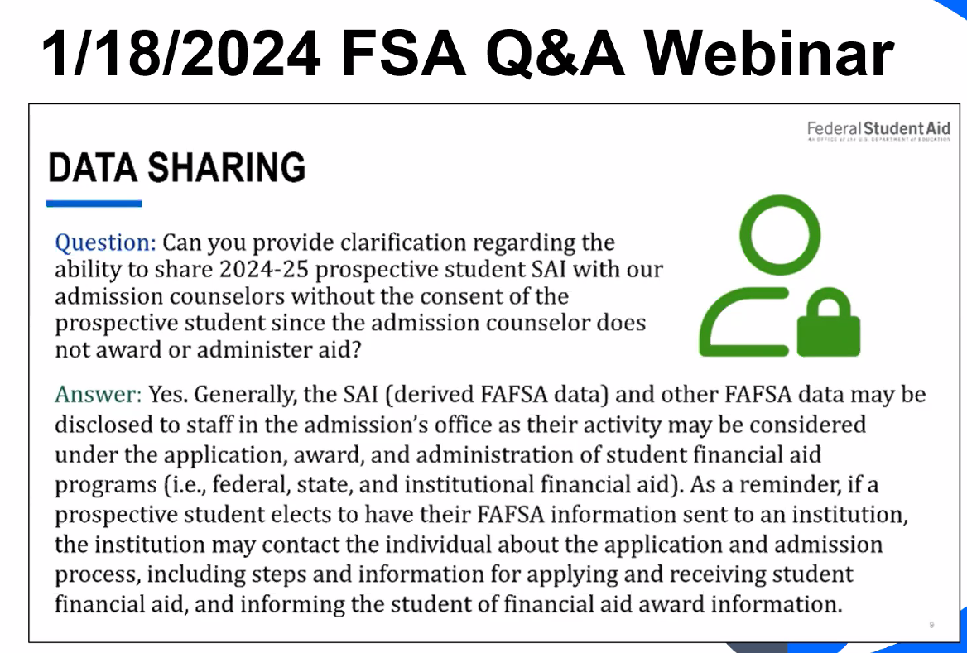

Q: Can FTI be shared with a **contractor** that assists in the awarding of institutional aid

1. Yes, as they carry out the application, award and administration of student financial aid programs.

Q: Can institutions disclose FTI if part of an Audit?

1. Yes

Q: Can federal tax information (FTI) from the FAFSA be accessed or disclosed to or be used by our TRIO Program?

1. It depends. General access and use of FTI data under the IRC must be consistent with the application, award, and administration of federal, state, and institutional financial aid programs. If the institution is determining student eligibility for and amount of a TRIO grant, then FTI data may be accessed, disclosed, used for such purposes. • FTI may not be used to generally determine student eligibility for the TRIO program (i.e., for additional student services and resources) as the program is not authorized under IRC (26 USC 6103(1)(13) and access to FTI data is prohibited beyond the scope of the application, award, and administration of federal, state, and institutional financial aid programs. • However, with written consent of the applicant, a TRIO advisor or other TRIO administrator may participate in discussions with a financial aid administrator for purposes of the TRIO program.